**Proyek ISYS6596003**

**Sistem Informasi Project User Experience Research and Design**

Kelas: BB11

Kelompok: 10

Anggota:

* Joevito Tanujaya – 2702274135
* Imanuel Hartanto - 2702273523



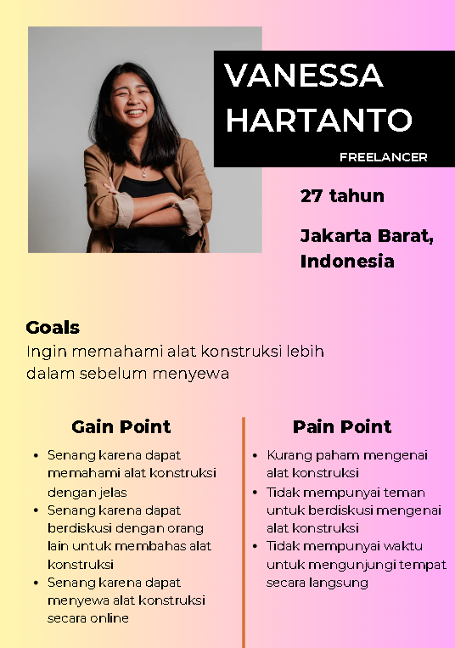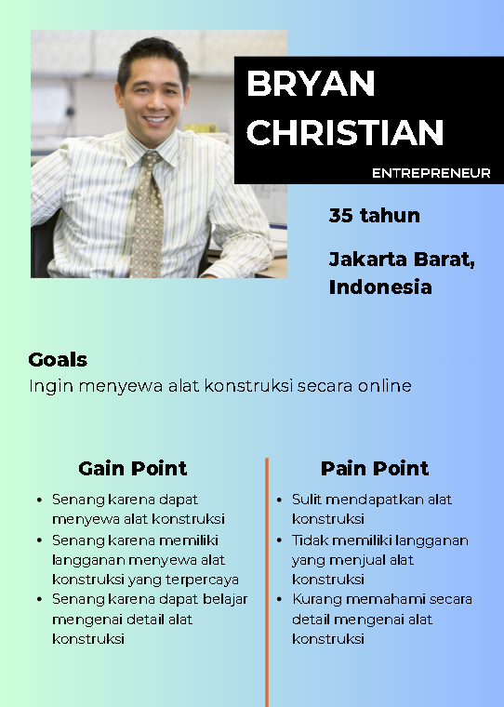**User Persona** <https://www.canva.com/design/DAGGV0jMEoY/o6UzDMRujqjgzIeZs_vBHQ/edit?utm_content=DAGGV0jMEoY&utm_campaign=designshare&utm_medium=link2&utm_source=sharebutton>

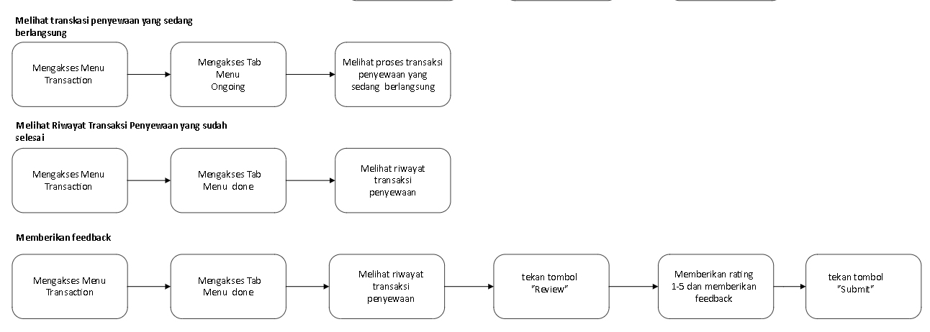**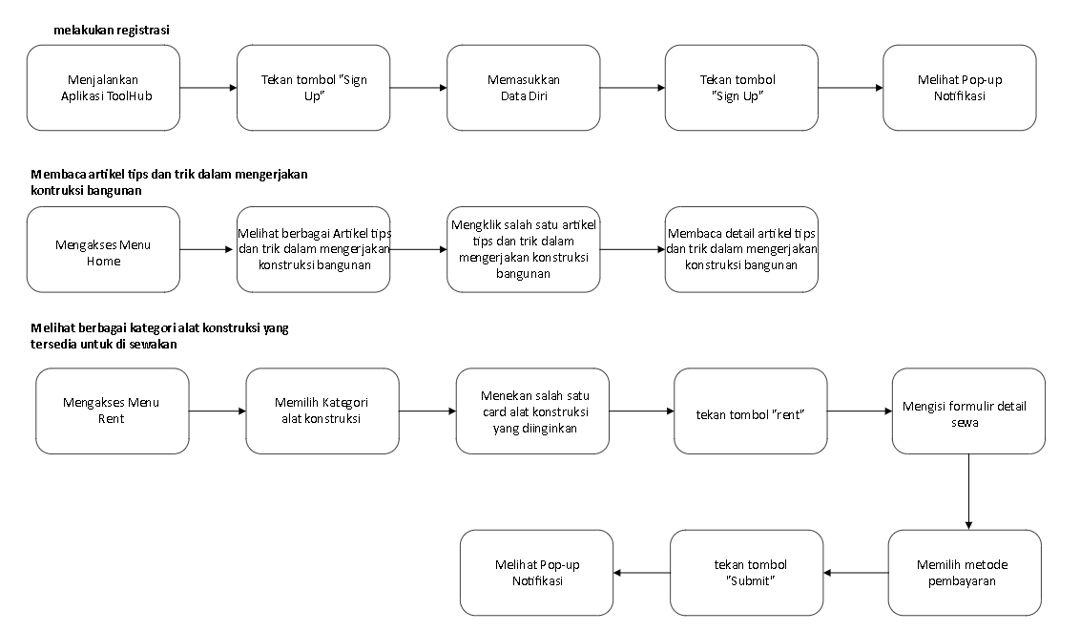Task Flow**

[Gambar1 - Copy.vsdx](https://binusianorg-my.sharepoint.com/personal/imanuel_hartanto_binus_ac_id/_layouts/15/guestaccess.aspx?share=ETMoel3Kp_1MmScGsvwViH4BRv7FVqEtbStSbTJJPRt5ZA&e=AYNsAe)

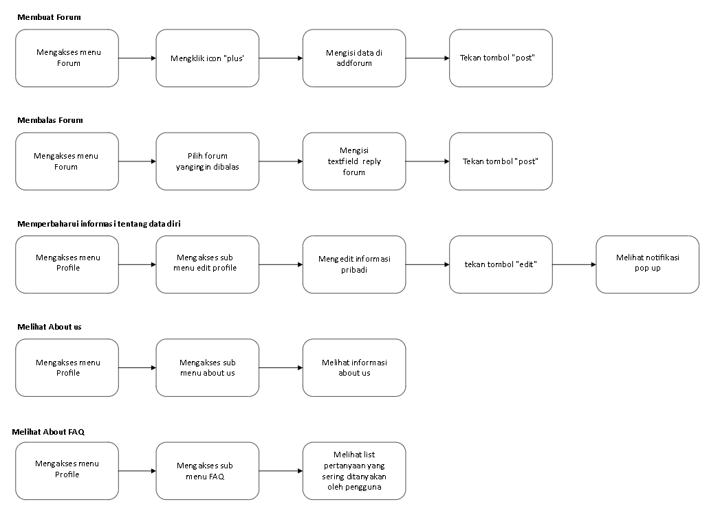

**Melihat FAQ**

Navigation Map

[Gambar1 - Copy.vsdx](https://binusianorg-my.sharepoint.com/personal/imanuel_hartanto_binus_ac_id/_layouts/15/guestaccess.aspx?share=ETMoel3Kp_1MmScGsvwViH4BRv7FVqEtbStSbTJJPRt5ZA&e=AYNsAe)

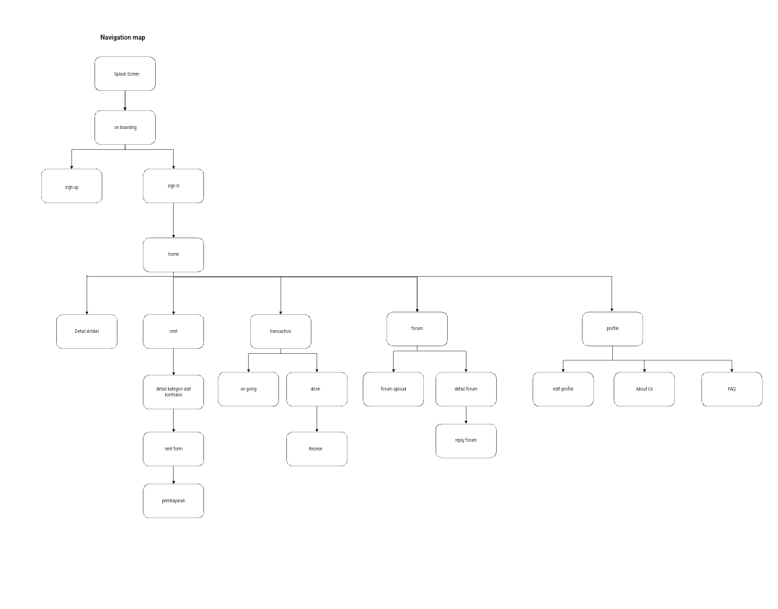

User Journey

[User Journey Proyek UX Lab.xlsx](https://binusianorg-my.sharepoint.com/personal/joevito_tanujaya_binus_ac_id/Documents/User%20Journey%20Proyek%20UX%20Lab.xlsx?d=w19324eb351b54e50853cc18ceb68bc87&csf=1&web=1&e=4UJn20&nav=MTVfe0U2Q0Q5REE1LUQ1NjgtNDA1MC04OEZELTQwMjU3NkQyN0M5Rn0)A close-up of a computer screen

Dokumentasi Referensi Proyek

1. <https://images.app.goo.gl/uyFaCKiNJKJxiECv5>
2. <https://www.google.com/imgres?q=alat%20konstruksi&imgurl=https%3A%2F%2Fproducts.unitedtractors.com%2Fwp-content%2Fuploads%2F2023%2F09%2F5.-Banner-Landscape-01-290823-5-Alat-Berat-Konstruksi-yang-Dapat-Meningkatkan-Efisiensi-dan-Produktivitas.jpg&imgrefurl=https%3A%2F%2Fproducts.unitedtractors.com%2Fid%2Fberita%2F5-alat-berat-konstruksi-yang-dapat-meningkatkan-efisiensi-dan-produktivitas%2F&docid=esFHjnuRng3Z0M&tbnid=MXzQv5Lnbcwf6M&vet=12ahUKEwiJ1o3SxsuGAxVai2MGHZG4COIQM3oECBoQAA..i&w=1230&h=635&hcb=2&ved=2ahUKEwiJ1o3SxsuGAxVai2MGHZG4COIQM3oECBoQAA>
3. <https://www.google.com/imgres?q=alat%20konstruksi&imgurl=https%3A%2F%2Fget.pxhere.com%2Fphoto%2Fwork-technology-tool-construction-vehicle-soil-machine-bulldozer-earth-build-blade-site-excavators-shovel-dig-excavation-dredge-construction-work-construction-machine-construction-vehicle-work-machine-backhoe-bucket-tracked-vehicle-construction-equipment-489611.jpg&imgrefurl=https%3A%2F%2Fpxhere.com%2Fid%2Fphoto%2F489611&docid=AoDAWEQDlLETaM&tbnid=g0O294KI861FkM&vet=12ahUKEwiJ1o3SxsuGAxVai2MGHZG4COIQM3oFCIEBEAA..i&w=4315&h=3235&hcb=2&ved=2ahUKEwiJ1o3SxsuGAxVai2MGHZG4COIQM3oFCIEBEAA>
4. [https://www.google.com/url?sa=i&url=https%3A%2F%2Fwww.indiamart.com%2Fproddetail%2Fasphalt-road-paver-finisher-4143682533.html&psig=AOvVaw3lpoaWO9AmejopZmOn7Nwi&ust=1717921012952000&source=images&cd=vfe&opi=89978449&ved=2ahUKEwjZk43PyMuGAxXxzTgGHc5KAoEQjRx6BAgAEBU](https://www.indiamart.com/proddetail/asphalt-road-paver-finisher-4143682533.html)
5. [https://www.google.com/url?sa=i&url=https%3A%2F%2Fcranemarket.com%2Fgrove-grt650-grt655-50-ton-rough-terrain-crane-for-sale-id17615&psig=AOvVaw2sSoeyr5IBBTRP5pwGb49V&ust=1717921073166000&source=images&cd=vfe&opi=89978449&ved=2ahUKEwjLrujryMuGAxUtyDgGHbOiBWkQjRx6BAgAEBU](https://cranemarket.com/grove-grt650-grt655-50-ton-rough-terrain-crane-for-sale-id17615)
6. [https://www.google.com/url?sa=i&url=https%3A%2F%2Fwww.made-in-china.com%2Fproducts-search%2Fhot-china-products%2FKomatsu_D60_Dozer_Price.html&psig=AOvVaw2TSBUELwAjZQE3BQ7TfxAC&ust=1717921117414000&source=images&cd=vfe&opi=89978449&ved=2ahUKEwjezfSAycuGAxX1T2wGHQN1C3gQjRx6BAgAEBU](https://www.made-in-china.com/products-search/hot-china-products/Komatsu_D60_Dozer_Price.html)
7. <https://www.google.com/imgres?q=Bangun%20Rumah%20Impian%20dengan%20Hemat&imgurl=https%3A%2F%2Fsgcka.co.id%2Fimages%2FArticle%2FNewsDetail-201702%2F390105%2Frencana-pembangunan-rumah-small.webp&imgrefurl=https%3A%2F%2Fsgcka.co.id%2Fdnews%2F340015%2F8-tips-hemat-membangun-rumah-impian.html&docid=MjBHhBEgxEeh0M&tbnid=tdn-OL2jiV5-HM&vet=12ahUKEwiK7PebycuGAxXt9zgGHU0KDucQM3oECEEQAA..i&w=300&h=213&hcb=2&ved=2ahUKEwiK7PebycuGAxXt9zgGHU0KDucQM3oECEEQAA>
8. <https://www.google.com/imgres?q=Bangun%20Rumah%20Impian%20dengan%20Hemat&imgurl=https%3A%2F%2Fstatic.promediateknologi.id%2Fcrop%2F0x0%3A0x0%2F0x0%2Fwebp%2Fphoto%2Fp2%2F56%2F2024%2F02%2F04%2F8-Cara-Membangun-Rumah-dari-Nol-dan-Hemat-Budget-Panduan-Lengkap-untuk-Pemilik-Rumah-Baru-1560933226.jpg&imgrefurl=https%3A%2F%2Fwww.idncitizen.com%2Fekonomi%2F564085048%2F8-cara-bangun-rumah-dari-nol-dan-hemat-budget-panduan-lengkap-untuk-pemilik-rumah-baru&docid=k3XhDfMPu387CM&tbnid=11v9SfbxH-rCCM&vet=12ahUKEwiK7PebycuGAxXt9zgGHU0KDucQM3oECB0QAA..i&w=700&h=526&hcb=2&ved=2ahUKEwiK7PebycuGAxXt9zgGHU0KDucQM3oECB0QAA>
9. <https://www.google.com/imgres?q=Kesalahan%20Fatal%20dalam%20membangun%20rumah&imgurl=https%3A%2F%2Fi.ytimg.com%2Fvi%2FKgcvZ62W4Og%2Fmqdefault.jpg&imgrefurl=https%3A%2F%2Fwww.youtube.com%2Fwatch%3Fv%3DKgcvZ62W4Og&docid=XujHkpXkkDidpM&tbnid=UcJmVsaxzOM8xM&vet=12ahUKEwijr4LNycuGAxX6wjgGHcBaARYQM3oECHIQAA..i&w=320&h=180&hcb=2&ved=2ahUKEwijr4LNycuGAxX6wjgGHcBaARYQM3oECHIQAA>
10. <https://www.google.com/imgres?q=excavator&imgurl=https%3A%2F%2Feecqemvzenj.exactdn.com%2Fwp-content%2Fuploads%2F2024%2F03%2F1-5.jpg%3Fstrip%3Dall%26lossy%3D1%26ssl%3D1&imgrefurl=https%3A%2F%2Fwww.garudasystrain.co.id%2Fmengenal-dan-mencegah-kecelakaan-kerja-pada-pengerjaan-excavator%2F&docid=yb4UVmZMHACmpM&tbnid=aQmXwL5AdhM3mM&vet=12ahUKEwjomc_vycuGAxU9-jgGHaXEDrEQM3oECFsQAA..i&w=901&h=577&hcb=2&ved=2ahUKEwjomc_vycuGAxU9-jgGHaXEDrEQM3oECFsQAA>
11. [https://www.google.com/url?sa=i&url=https%3A%2F%2Fwww.pavingequipment.com%2Flistings%2Ffor-sale%2Fwheeler-machinery-ogden-utah%2Fasphalt-slash-pavers-slash-concrete-equipment%3FLocationID%3D350000094701&psig=AOvVaw3aC_UPo93D7mRaTp6vT4vV&ust=1717921533643000&source=images&cd=vfe&opi=89978449&ved=2ahUKEwjvzbHHysuGAxVP2TgGHZEiAGcQjRx6BAgAEBU](https://www.pavingequipment.com/listings/for-sale/wheeler-machinery-ogden-utah/asphalt-slash-pavers-slash-concrete-equipment?LocationID=350000094701)
12. [https://www.google.com/url?sa=i&url=https%3A%2F%2Fhvin.co%2Fspacereclaimer&psig=AOvVaw1U9fumwdvLE1E7YpiJogWB&ust=1717921619927000&source=images&cd=vfe&opi=89978449&ved=2ahUKEwjm_cPwysuGAxXV8zgGHYrHFiwQjRx6BAgAEBU](https://hvin.co/spacereclaimer)
13. <https://www.youtube.com/watch?v=hHICRXxjavA>

**Wireframe** <https://www.figma.com/design/l3G33yQGortgATWBzx2dKv/Kel-10---Wireframe-Project?node-id=0-1&t=SFGnEtpK3CPuZgrZ-1>

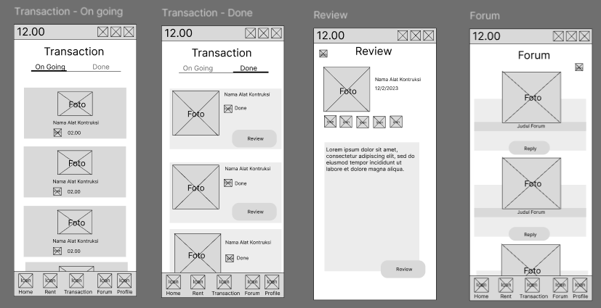

Wireframe (Flow)

<https://www.figma.com/design/l3G33yQGortgATWBzx2dKv/Kel-10---Wireframe-Project?node-id=41-206&t=SFGnEtpK3CPuZgrZ-1>